Everything in javascript happens inside execution context. U can assuse it as a bigbox where whole js code will get executed.

**Execution context – will have 2 components in it –**

1)**memory component-** here all variables and funcs are stored as key value pairs eg: a:10 , func: {…}

Memory comp also known as **variable environment**.

2)**code component**- it is the place where code will get executed one by one line

It is also known as **thread of execution**. It is like a thread where whole code is executed- one line at a time.

* Javascript is synchronous and single threaded language.

It means js can execute one command at a time and in specific order (one by one)

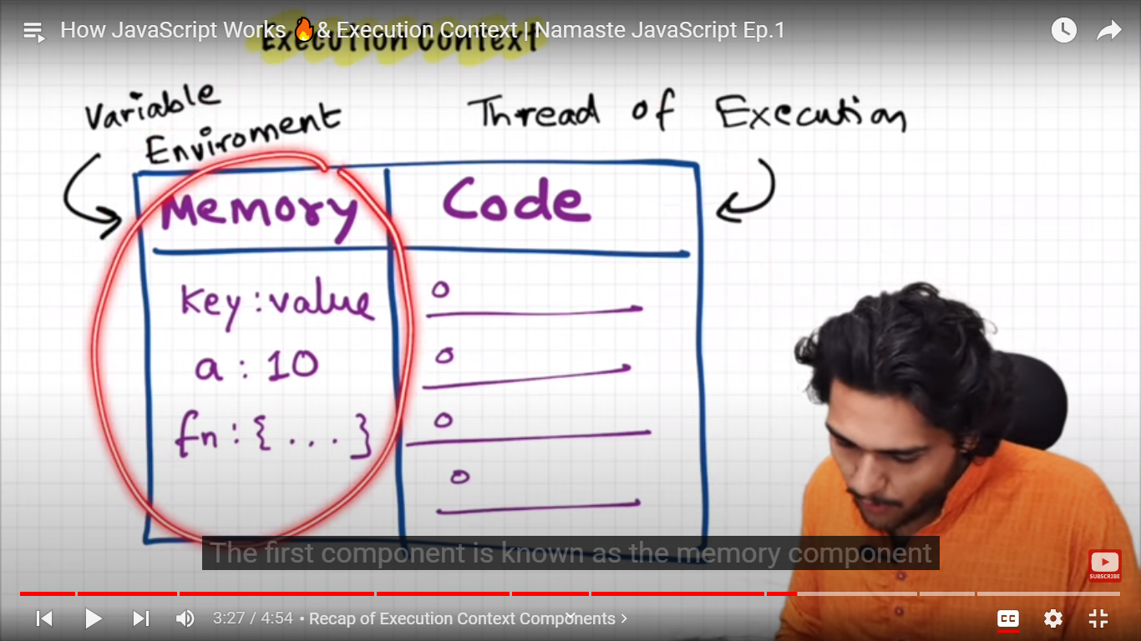

**Day 2: What is call stack?**

Lets take some example code

        var n=2 ;

        function sqaure(num){

            var ans=num *num;

            return ans;

        }

        var square2=sqaure(n);

        var sqaure4=sqaure(4)

add this inside script tag

when u run this whole code, a execution context will get created.

This execution context will be created in 2 phases –

1. Memory Creation phase
2. Code execution phase

In first phase , js will allocate mem to all variables and functions

**Process:**

At line one, it will allocate memory to n in memory comp – eg: n:

At line two ,it allocate memory to function square in mem comp – eg: square:

It stores its values as undefined in case of variables .

In case of functions , it stores the whole code as its value

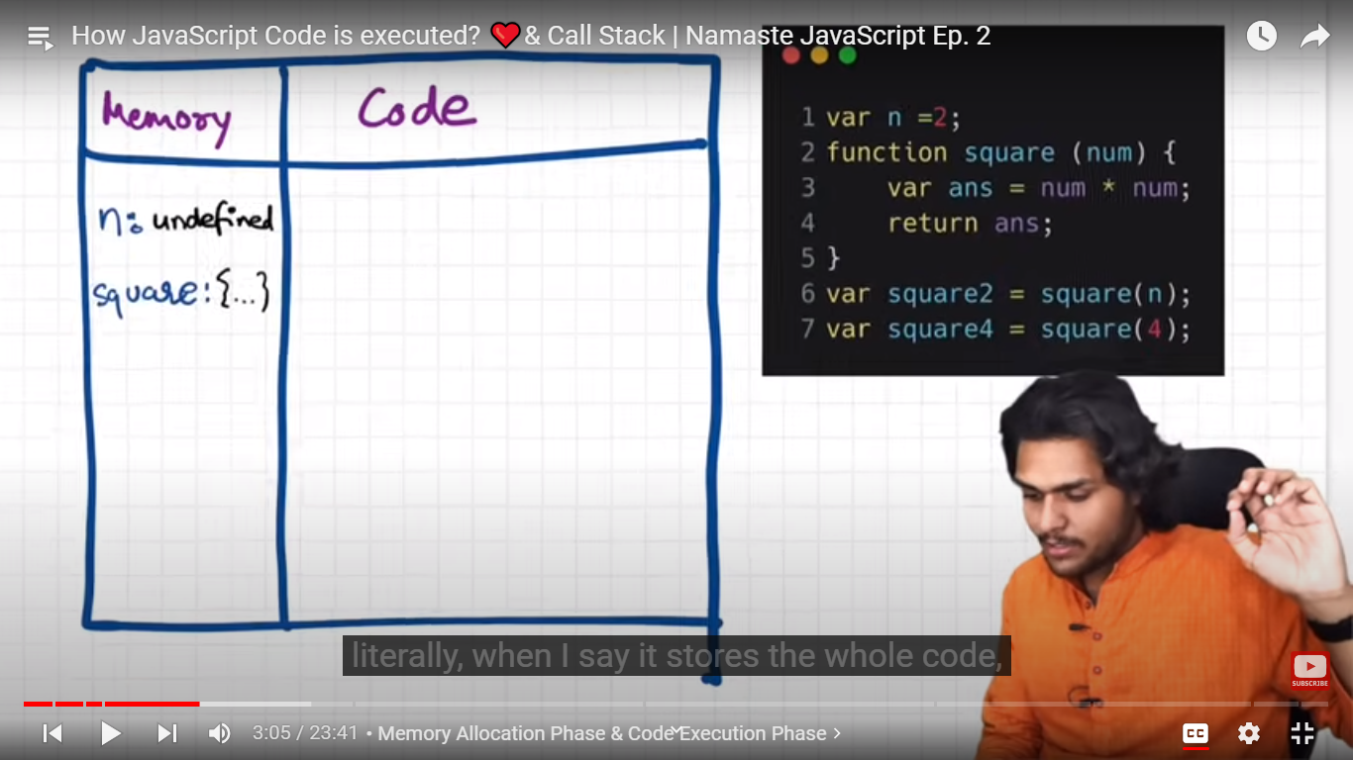

It also store memory for sqaure2 and square 3, as they are variables, their value will be undefined

Code execution phase: 2nd phase- after mem allocation, the 2nd phase will start

Here code actually gets execute, js will run whole code once again and now it executes code.

Var n=2 , 1st line , now value 2 will be get placed in place of undefined at identifier/holder n

Form line 2 to 5 – there is nthng to execute .

Then line 6- we invoke a function.

A function is a like a mini pgm

Whenever a func gets called, a new execution context will get created

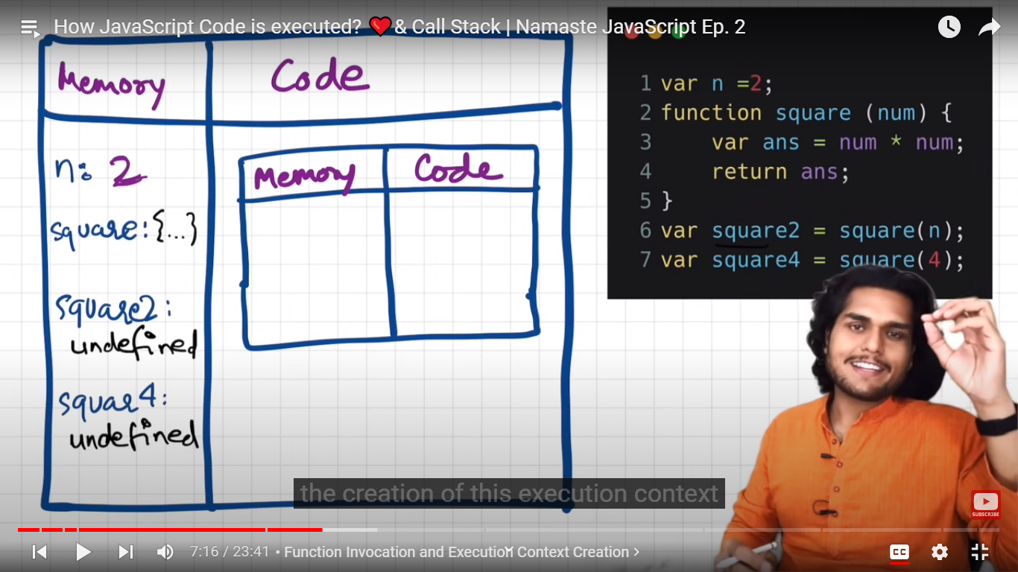

Again there will be 2 phases inside this nested execution context.

**Phase1: mem allocation to vars(parameter and variables) and funcs( which are inside square func only)**

Allocation mem to num and ans – we get its values as undefined.=> only allocation of mem done, no assignment of values.

**Nested Memory comp:**

**Num:undefined**

**Ans:undefined**

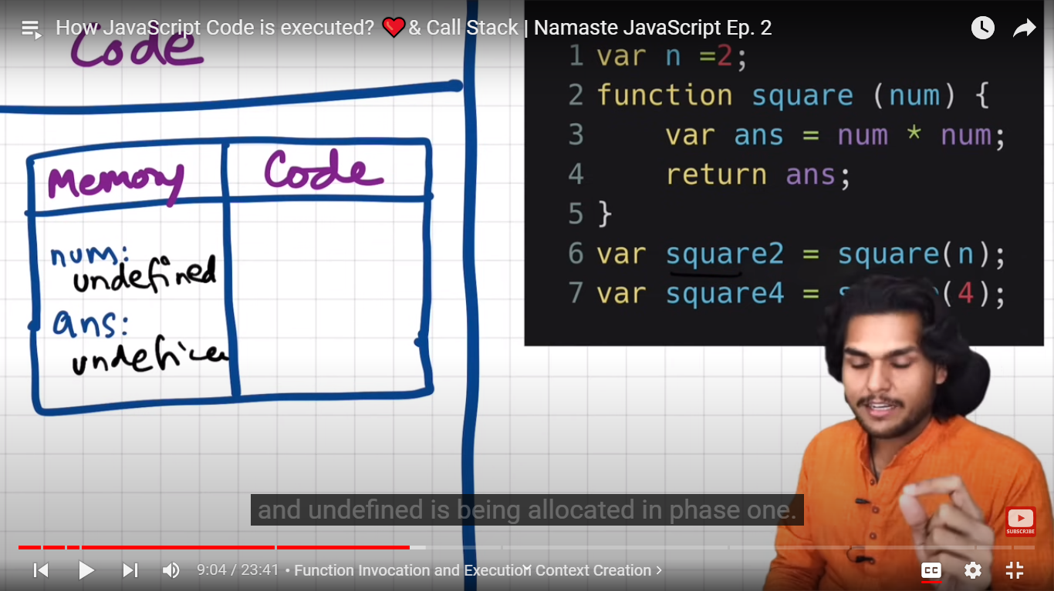

**Phase2: code execution phase**

Whenever we called the func here square(n) here the n value – whichc is 2 will get passed to the function

Num is known as parameter of function

N is known as argument .

* The parameter which we pass to func while calling it is known as argument
* The parameter of func in function definition is known as a parameter.

Now

Nested mem comp:

num:2

next line ans=num*num

it will calculate value (num*num ) in code comp and then replace undefined value of ans with the calculated value

|  |  |
| --- | --- |
| Mem comp | Code comp |
| num: 2 | Num*num |
| Ans= 4 |  |

Now return ans line – return stmt will return control back to execution context where the func was invoked.

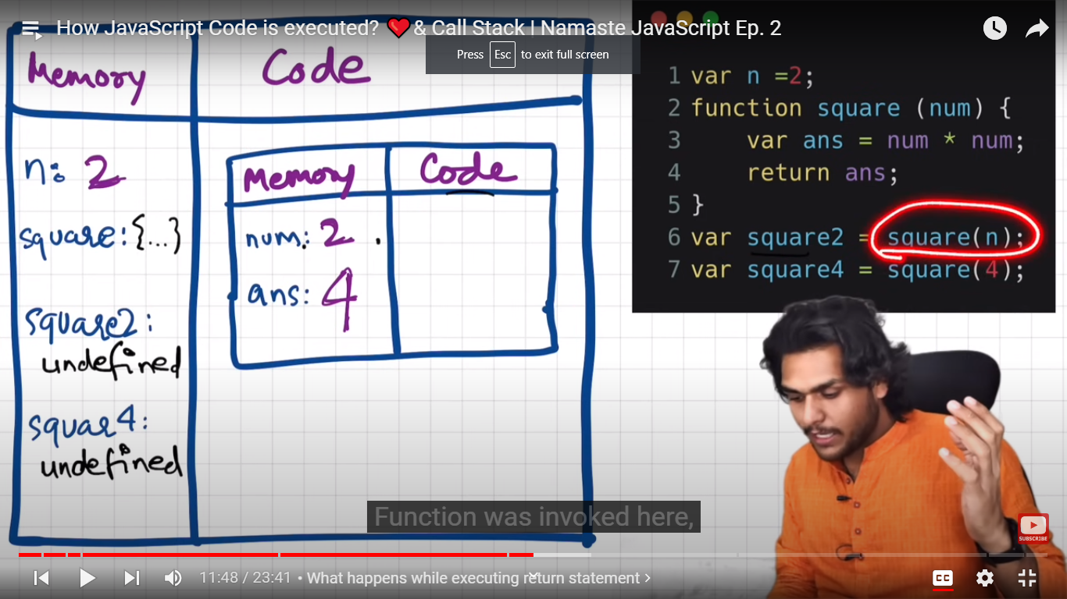

Func was invoked here at sqaure2

Now value 4(ans) will get replaced with undefined value of sqaure2().

When the func is executed totally and returned, then its execution context instance will get deleted.

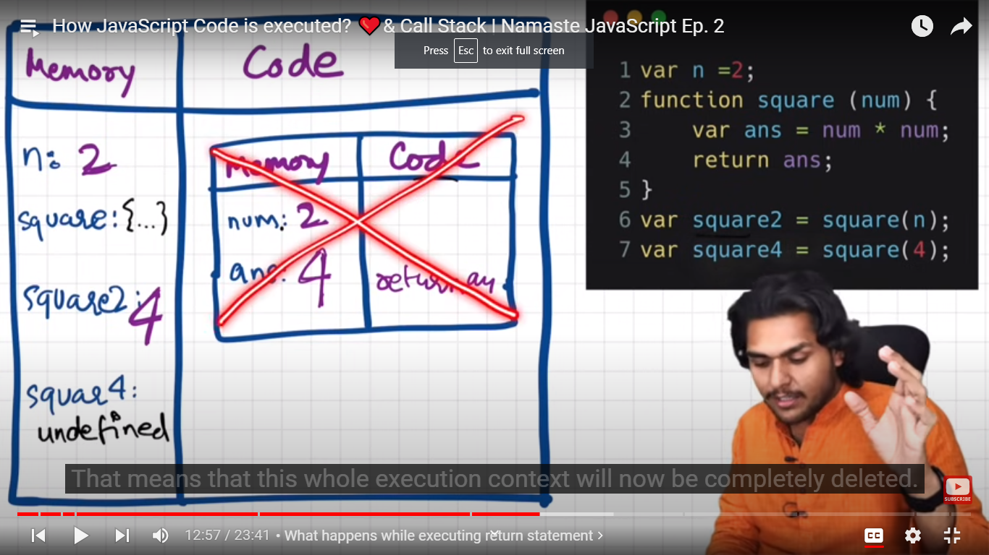

Now line 7- var suare4=square(4)

Again a new execution context created . same process

1st phase:

Num:undefined

Ans:undefined

2nd phase:

num:4

ans= 16

then this execution context deleted

square4: 16

now js done with whole work, whole pgm execution . now whole global execution context get deleted.

Suppose we have more nested functions- then need to create ,delete and manage many execution contexts.

So to manage it, js engine maintains a callstack

Call stack:

Is like a stack, in bottom we have global execution context,this whole execution context will get pushed into stack.

Whenever a new func gets invoked, a new execution context gets created on top of it.

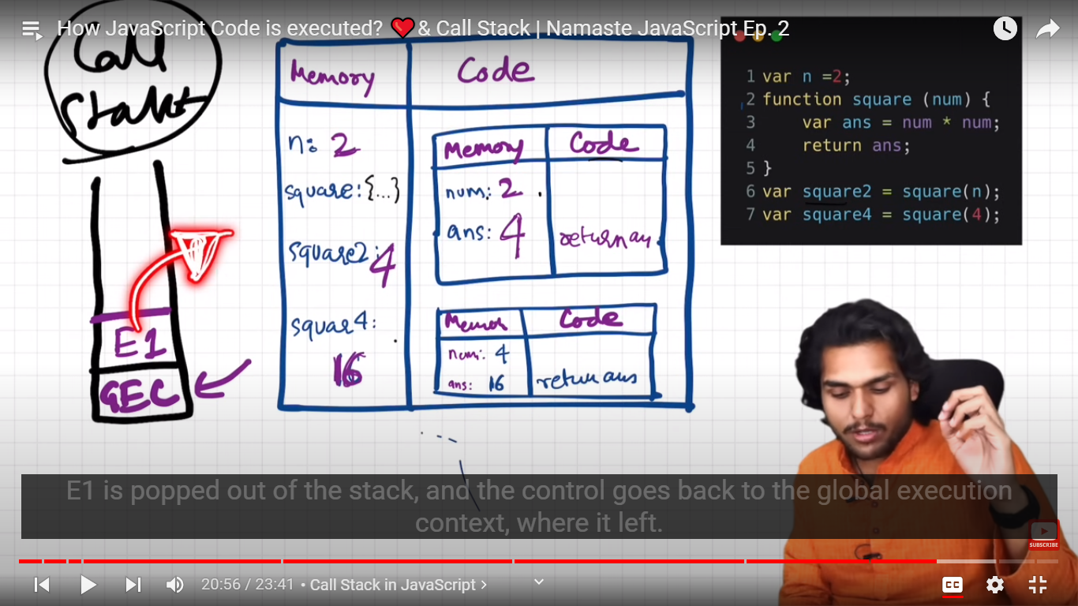

So call stack will only manage all execution contexts.

**Callstack maintains the order of execution of execution contexts.**

Callstack also known as

1)execution context stack

2)pgm stack

3) cntrl stack.

4) runtime stack

5) machine stack.

**Day 3:**

* **Hositing in Javascript:**

**Let**  us create a variable and a function . and call that func and print that variable

        var x=7;

        function getName(){

            console.log('namaste javascript')

        }

        getName();

        console.log(x)

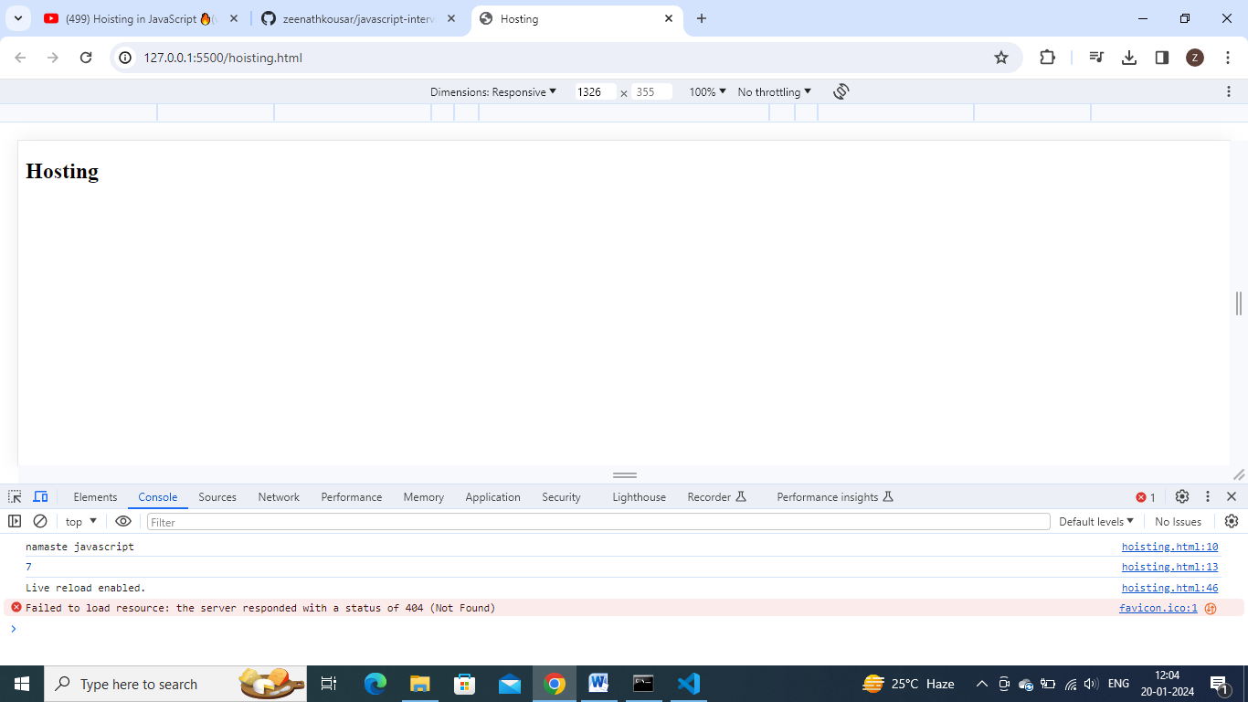

Now copy and paste that printing var and calling func stmts on to the top.

    <script>

         getName();

        console.log(x)

        var x=7;

        function getName(){

            console.log('namaste javascript')

        }

    </script>

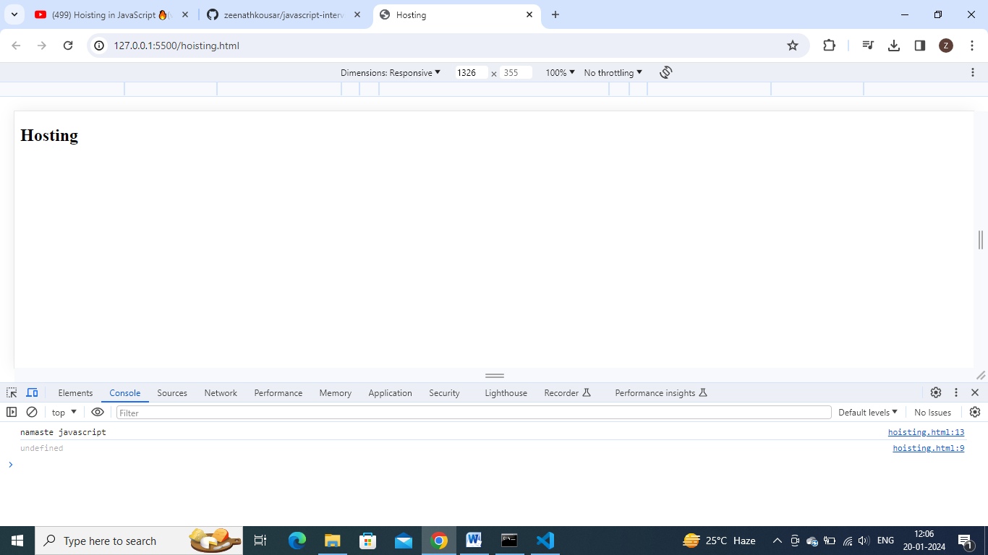

**In remaining pgmg languages – it gives err – u cannot access variable witout/before initialization and we cannot call a func without/ before defining it.**

**In javascript.**

**Somehow func is getting called , but variable got undefined.**

    <script>

         getName();

        console.log(x)

        // var x=7;

        function getName(){

            console.log('namaste javascript')

        }

    </script>

Remove var x=7 line , u get error now

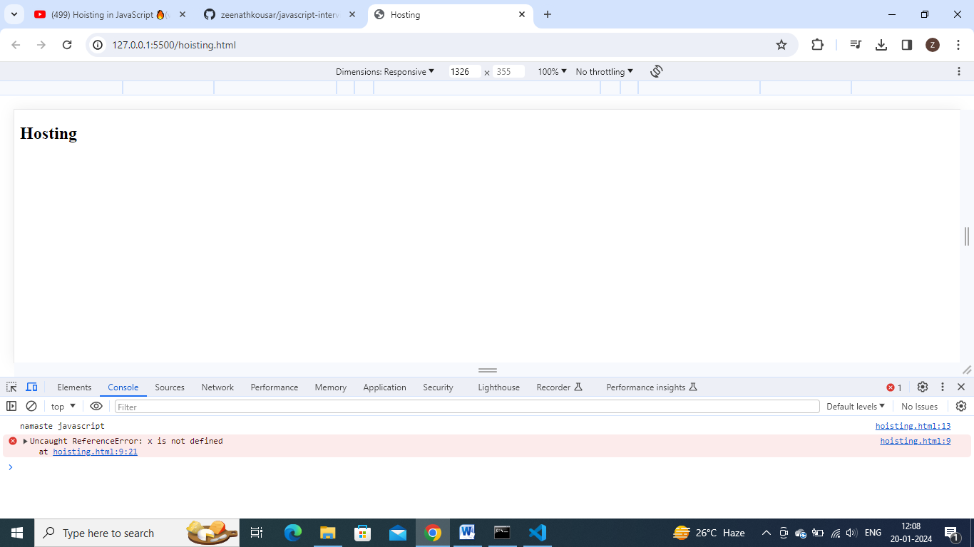

U get reference err – x is not defined

**Hoisting : is a phenomenon in js, In which u can access these variables and funcs even before initializing it. U can access it without any err.**

        var x=7;

        function getName(){

            console.log('namaste javascript')

        }

        console.log(getName)

console.log(getName) – will print func code as output.

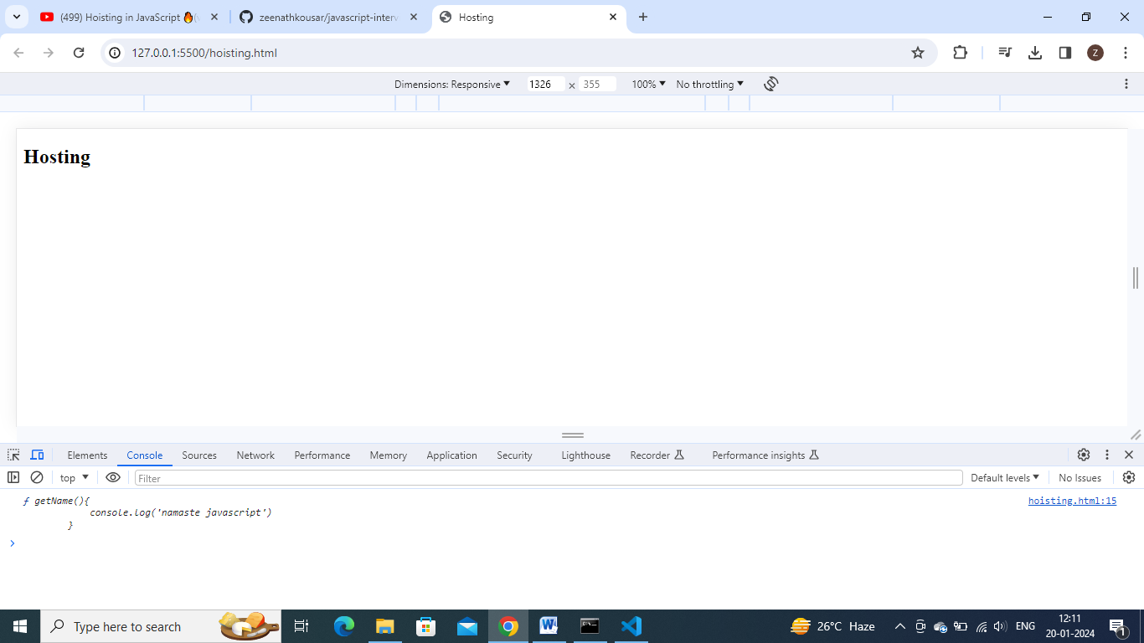

        console.log(getName)

        var x=7;

        function getName(){

            console.log('namaste javascript')

        }

**Moving console.log(getName) to upside , also we got same func code as output.**

So in case of variable x => console.log(x) before initialixing is getting undefined

But console.log(func) before initializing func, we get func code.

Bcoz run this code in terms of memory execution and code execution.

        var x=7;

        function getName(){

            console.log('namaste javascript')

        }

        getName();

        console.log(x)

        console.log(getName)

**reason: so funcs , before running/ before execution (2nd phase) only, funcs will get initialized with func code, but vars initialize with undefined-**

run and check memory wise this code .:

phase 1:

mem comp

x:undefined

getName: {….}

**reason: so funcs , before running/ before execution (2nd phase) only, funcs will get initialized with func code, but vars initialize with undefined-**

phase2:

x:7

        getName();

        console.log(x)

        console.log(getName)

        var x=7;

        function getName(){

            console.log('namaste javascript')

        }

Notdefined vs undefined:

A variable got memory but not initialized with a value => undefined

A variable did not got memory => undeclared

        getName();

        console.log(x)

        console.log(getName)

        // var x=7;

        function getName(){

            console.log('namaste javascript')

        }

In this code at console.log(x) line, x is not present in memory . so got undeclared error.

**Arrow funcs:**

        getName();

        console.log(x)

        console.log(getName)

        var x=7;

        // function getName(){

        //     console.log('namaste javascript')

        // }

        var getName=()=>{

            console.log('namaste hello')

        }

**As arrow funcs – means assigned func value to a variable=> err**

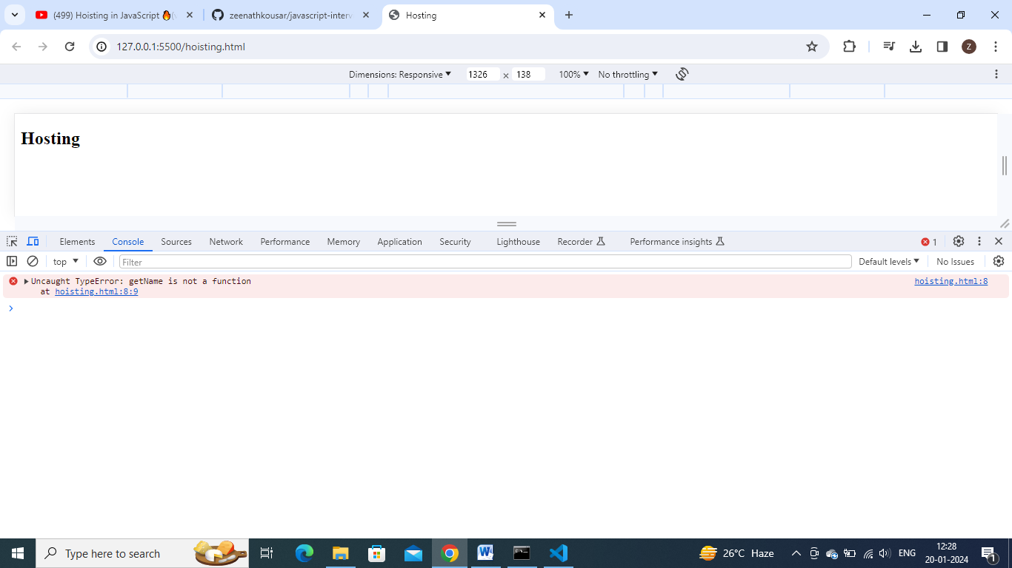

**Arrow func behaves like a variable.**

        //another way to define func

        var func2= function getName (){

        }

**In this way also,It work as a variable**

**Day 4: how functions work in js and variable environment:**

Lets see how function invocation behaves behind the scene.

var x=1;

a();

b(); // we can invoke or call funcs even before its initialization, bcoz of hoisting.

console.log(x) //1

function a(){

    var x=10;

    console.log(x); //10

}

function b(){

    var x=100;

    console.log(x);//100

}

Here we have a global variable x initialized with value 1

In function a – have x variable with value 10

In function b- have x variable with value 100

So we have same varible all over there, how js pgm behave

Lets see how js handles such scenario.

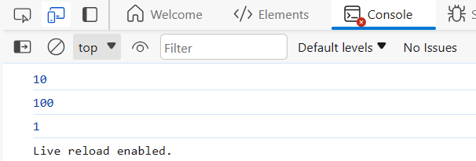

Execution :

1st phase: memory allocation

X: undefined

A:{…}

B:{….}

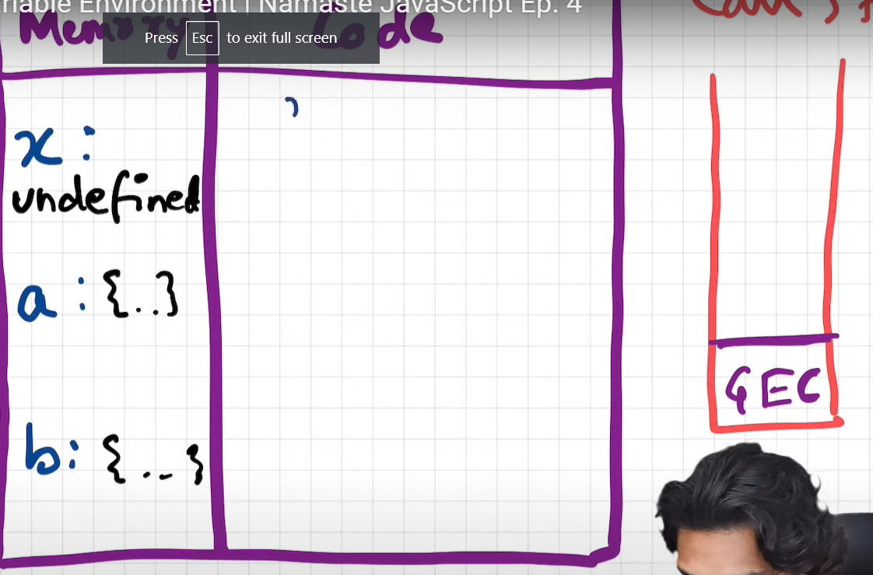

2nd phase:

Var x=1 => will replace x value undefined with 1.

A() => func invoked => a new separate execution context created- and pushed to callstack

Mem allocation : x: undefined

Execution comp : x:10 , console.log(x) – it sees for x value in local mem context . x:10

Then this particular separate execution context get popped from stack and cntrl moved to line no 2 where the a() func got called.

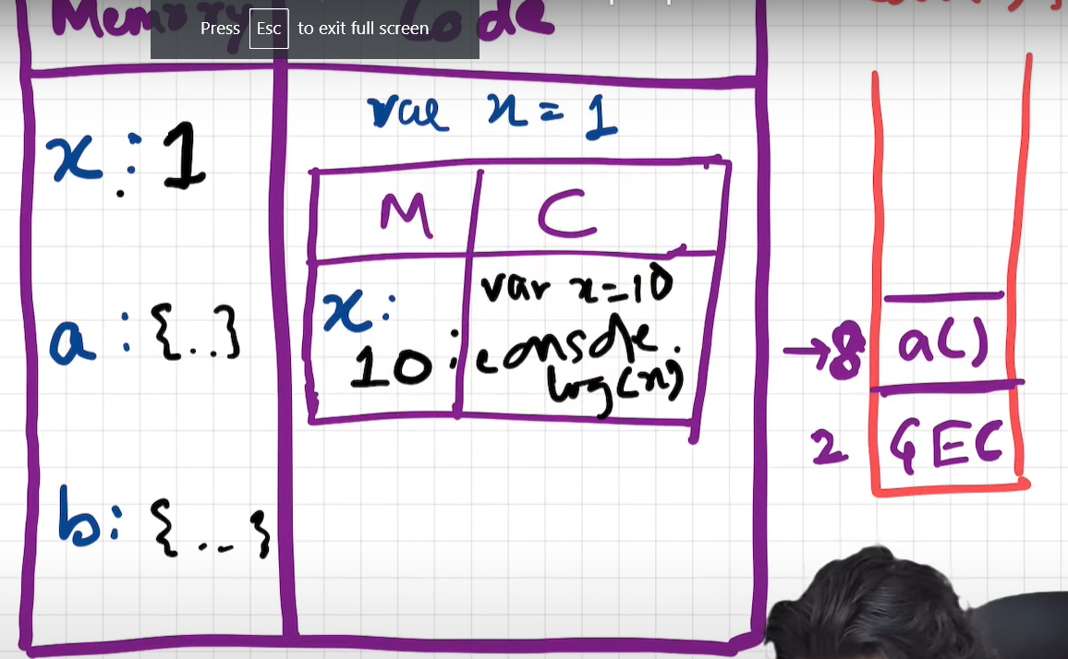

B() = same process => x:100

After whole process its particular execution context getx removed

Line 4: Console.log(x) =it checks for x value in its local context(GEC) – x:1

Now global execution context will also gets deleted from callstack.

**Day 5: window and this keyword:**

**Index.js**

Keep this file empty- then also js engine creates window object

Type window in console

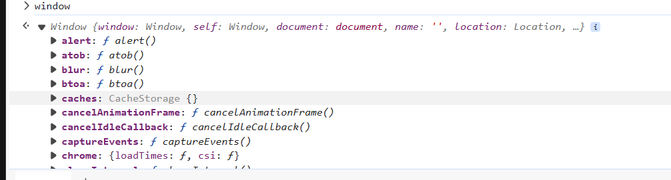

U got an obj with many functions inside it

These funcs and variables created by js engine into global scope/global execution context – u can access these funcs and varibles anywhere , in any pgm

Also js engine create this keyword. – at global level ‘this’ keyword points to window obj

**Window obj- is a global obj created along with global execution context**

So whenever a pgm is running, a global obj is created,a global execution context is created and a this keyword is created

This global obj , in case of browsers is known as window

But js can on servers or lot of other devices also

Wherever js is running there must be a js engine there

Here in chrome , we have v8 engine, maxilla firefox, safari all have its own js engine

So all js engines have a responsibility to create their global obj.

Everywhere global obj name will be different.

At the global/base level in global execution context this === window

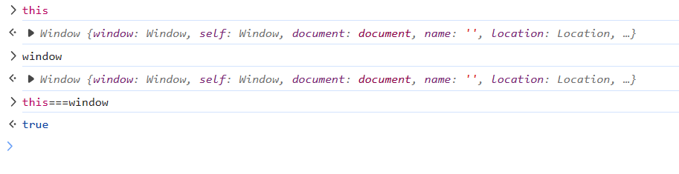

Global space meaning – any code which u write outside a function

var a= 10; //global space



function b(){

    var x=10; //local space



}



Now we created variable and a function in global space, now our .js file is not empty.

Now these global variable and func gets attached with global obj,window.



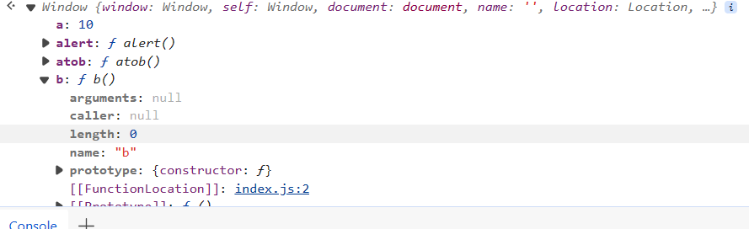



X is not there here. Global obj a is there, func is there



console.log(window.a);

console.log(a);

if u wont put anything before it , it refer to window obj/global space.

But to access varible x(local obj):

console.log(x);

console.log(this.a) // here 'this' refer to global obj - so output 10

var a= 10; //global space

function b(){

    var x=10; //local space

}

console.log(window.a);

console.log(a);

console.log(this.a) // here 'this' refer to global obj - so output 10

console.log(x);

so window.a , a ,this.a all refering to global space only

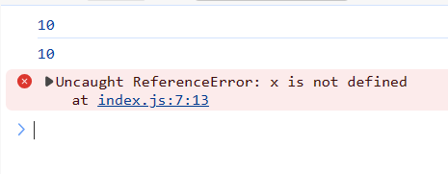

Got reference error

Becoz if we wont put anything before x it finds x in global scope.

It wont find x in global space, so err

**Day 6: undefined vs not defined**

Undefined => memory allocated but value not defined

Not defined=> reference err , variable is not defined.

var a= 10;

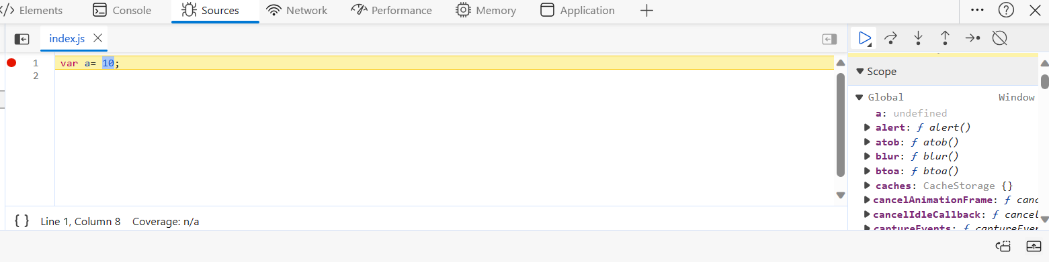

Adding debugger at this line or stop execution at this line, before execution of this line

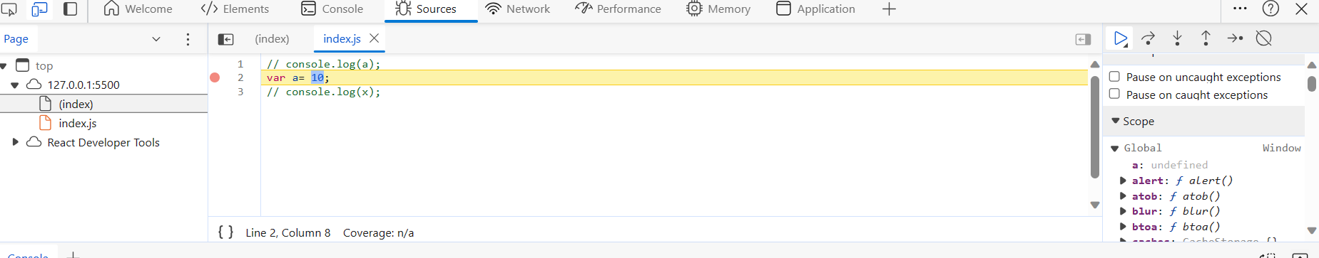

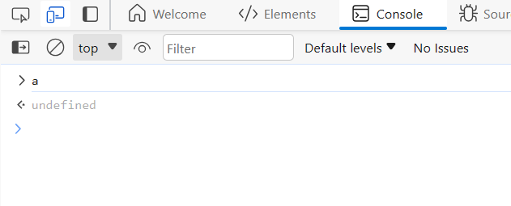

See at this line only mem comp is executed => a value is undefined , mem got reserved for a , but value is not assigned

var a= 10;

console.log(x);

now do console.log(x) – x is not defined , not allocated mem – so not defined , reference err

console.log(a);

var a= 10;

**output:**

undefined

console.log(a); //undefined

var a= 10;

// console.log(x);

console.log(a); //10

undefined means-it is a keyword /placeholder which takes memory. It is placeholder kept until the varible is assigned some other value. var a;

console.log(a); // a is not assigned any value so it will be undefined

// var a= 10;

// console.log(x);

// console.log(a);

if(a=== undefined){

    console.log('a is undefined')

}

else {

    console.log('a is not undeinfed')

}

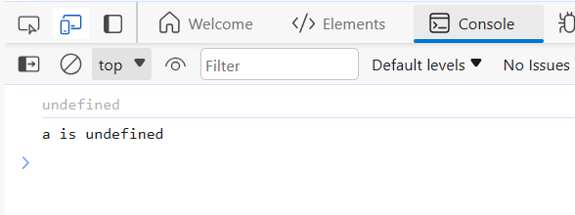

var a;

console.log(a); // a is not assigned any value so it will be undefined

a=10 // now that undefined is replaced with 10.

if(a=== undefined){

    console.log('a is undefined')

}

else {

    console.log('a is not undeinfed')

}

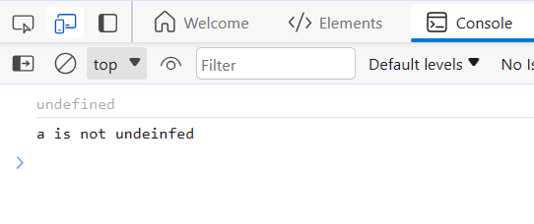

**Datatypes:**

**Javascript is loosely typed language or weekly - it does not attaches a variable to a specific datatype**

Eg: I created a variable a var a= 10

Later in the pgm , I can keep string in it, or Boolean in it.

In other languages if we do String a=’some value’ , later it cant hold numbers or Boolean etc

var a;

console.log(a);

a=10;

console.log(a);

a='hello world';

console.log(a)

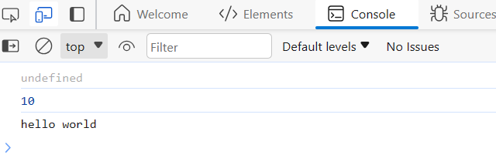

It is not good practice to assign a variable manually as undefined.

a=undefined;

console.log(a)

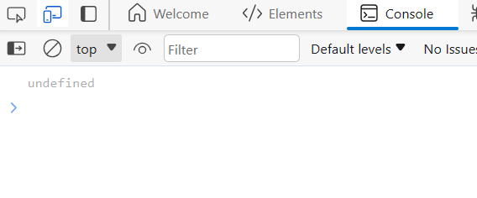

Though we get proper output as undefined , no err

But it is not good practice , bcoz in js undefined keyword is a placeholder to keep for a variable which is not assigned yet a value.

**Video 7: Scope Chaining and Lexical Environment:**

**Scope in js is directly related to lexical environment**

function a(){

}

var b=10;

a();

lets have a function and a variable b like this

Q. can we access varible b inside function a

function a(){

    console.log(b); // get output as 10 , somehow function is able to access global var b

}

var b=10;

a();

function a(){

    c();

    function c(){

    console.log(b); // get output as 10 , somehow function is able to access global var b

    }

}

var b=10;

a();

created another func c() inside function a() – then also got output as 10, means inside func can also access outside global var

lets check viceversa case:

b is declared inside func, try to access b outside

function a(){

    var b=10;

    c()

    function c(){

    }

}

a();

console.log(b)

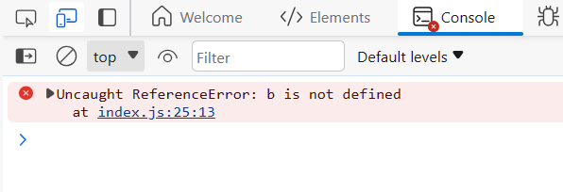

Scope : means where u can access a specific variable or func in a pgm.

Execution in terms of call stack

Line 1: function a() {….}

Mem comp:

A:{…..}

Line : a() calling func – another separate execution context created and get pushed to stack

Mem comp:

B: undefined

C:{….}

C() => another execution contex for func c will be created and get pushed to stack

So wherever a execution context is created, their lexical env also gets created

So **lexical env is the local mem along with lexial env of its parent.**

**Lexical -term means in hierarchy or in a sequence ,**

**C is lexically inside a function**

**Where that code is present physically inside the code**

**So c is present physically inside a func , so c is lexically inside a ()**

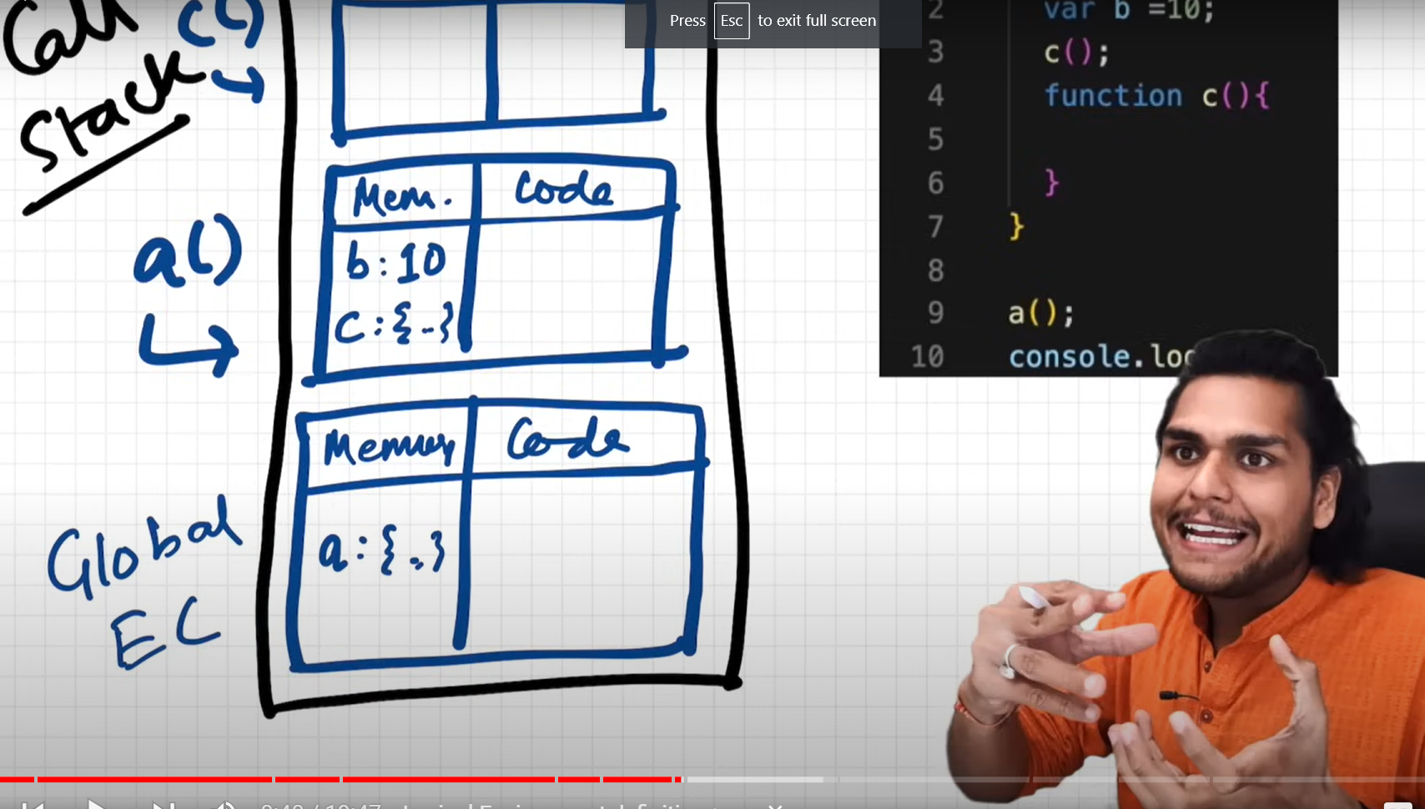

**So whenever , I say ,lexial env – that means local mem and lexical env of parent**

**So environment context of c will have access to lexical env of a()**

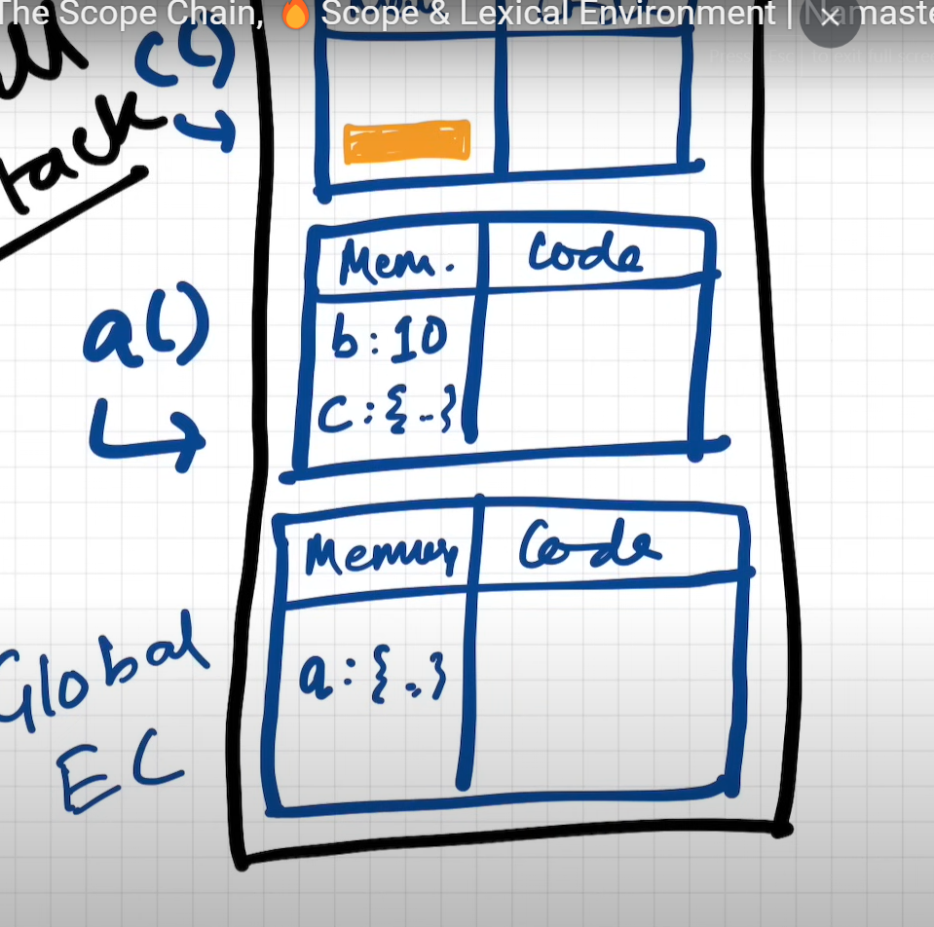

**The orange box here, can be thought of as a reference to lexical env of parent a()**

**So lexical parent of c is a()**

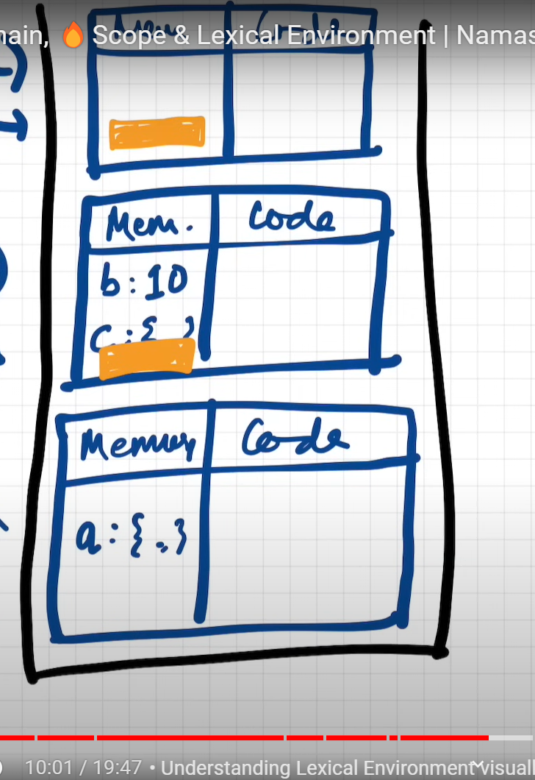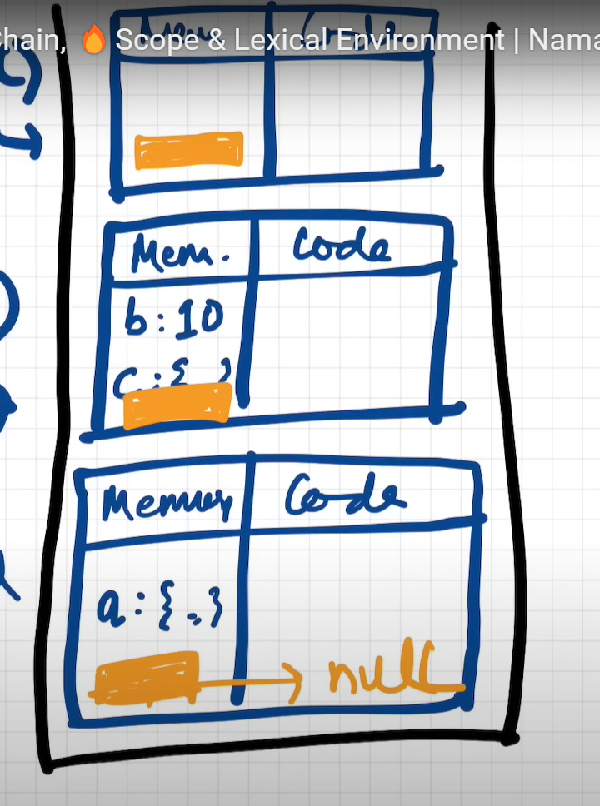

**In a() , it points to global ,null**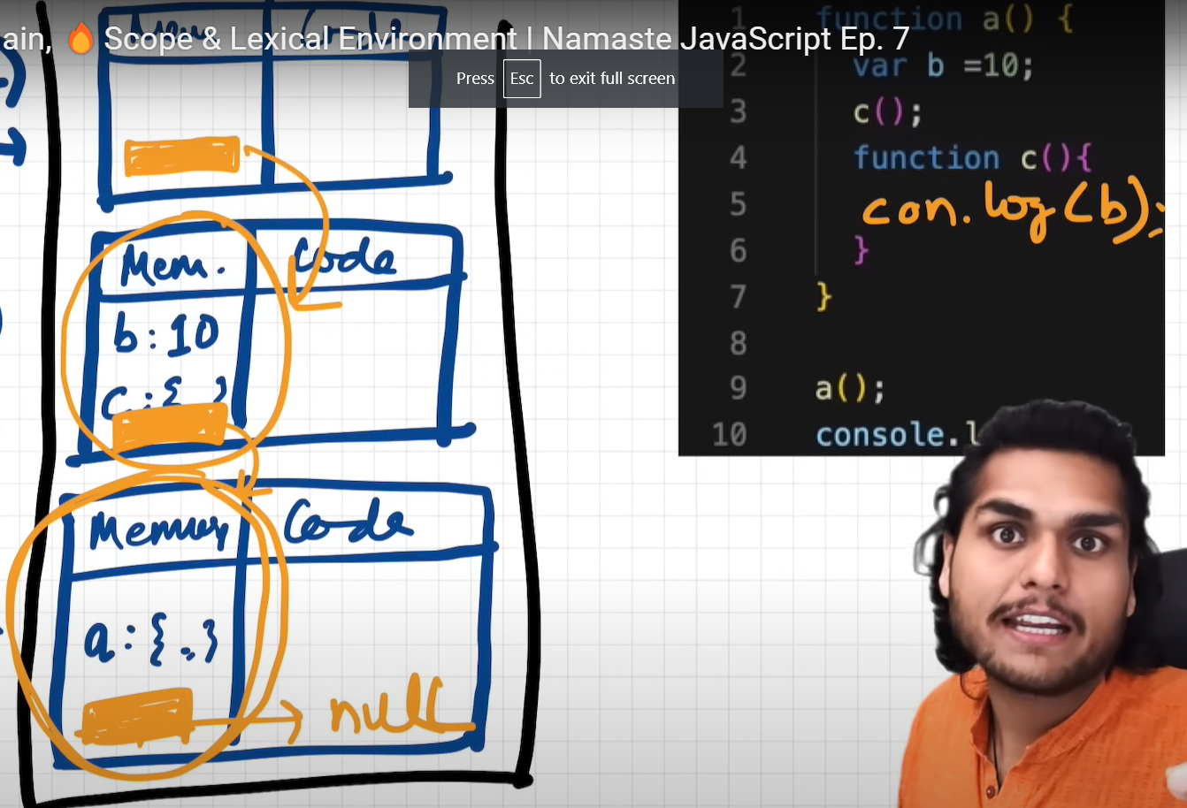

**In this case , dng console.log(b) inside c() func=> in its mem no b var exists, it then checks in parents lexical env=> yes exists, so it can access. It search in parent a() first , not found then check in global execution.**

**This mechanism of finding variable b – is known as scope chain**

**Scope chain- is a chain of all these lexical env and its parent references.**

**Video 8: Let and const hosting and temporal dead zone:**

Are let and const declarations get hoisted:

Syntax err vs refernce err vs type err

Yes let and const decalrations will also get hoisted but differently than var.

They will be hoisted but will be in temporal dead zone for time being

let a=10;

var b=100;

in previous videos we learned that we can access b even before initialization, but value will not be assigned, will get undefined – it because of hoisting

console.log(b);

let a=10;

var b=100;

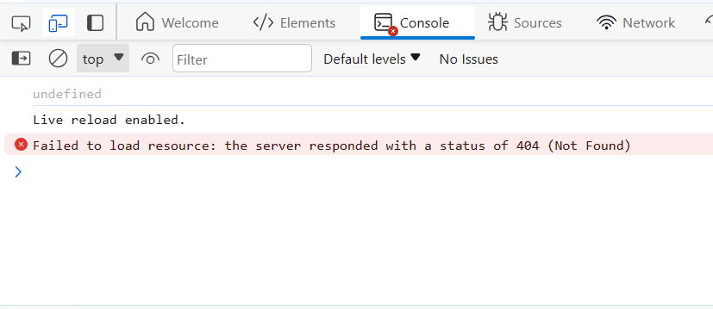

console.log(a);

let a=10;

var b=100;

see now output:

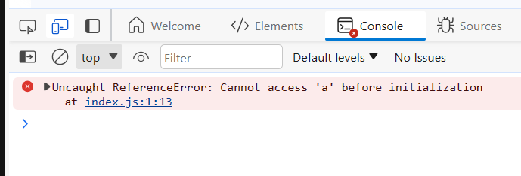

It means we can access a only after assigning some value to it

let a=10;

console.log(a);

var b=100;

if we try to access it after initialization , then we can access it .

lets see inside to check whether this variable ‘a’ which is declared using let will get hoisted or not. Will it get memory or not

adding debugger at line 1 , before initialization of a 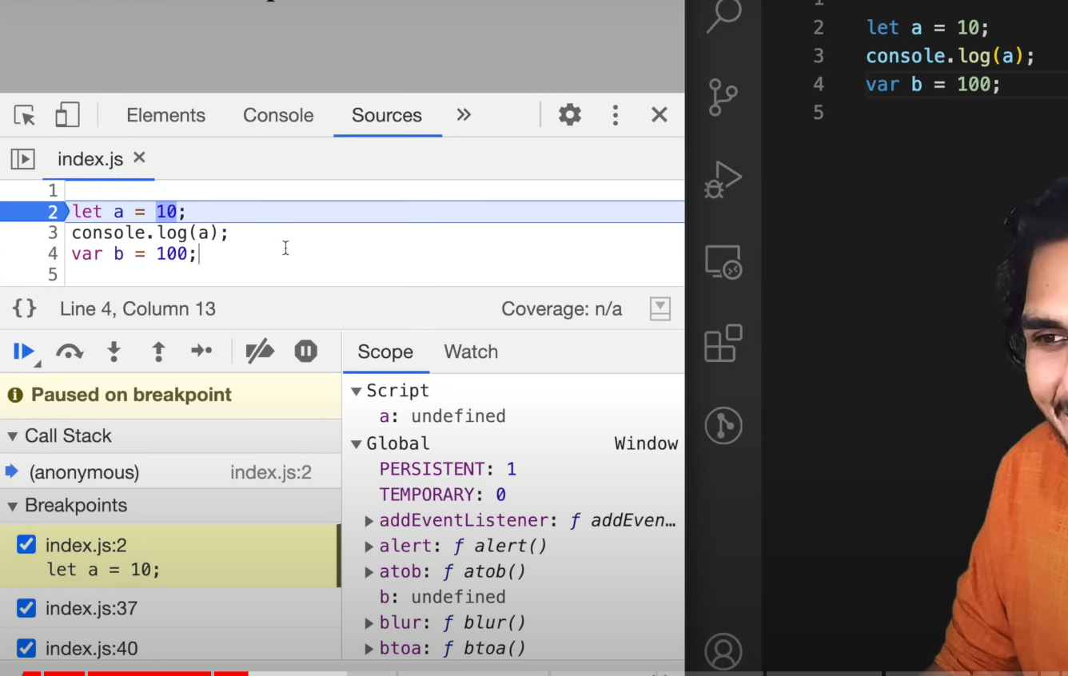



got a some memory – undefined and b-undefined

in case of var b- it is in global scope, but let a is insome script,

so b got assigned some memory and attached to global obj

but In case of let and const, they also allocated mem , that is hositing ,but they get stored in separate memory space, and u cannot access this let and const values until u added some value into it

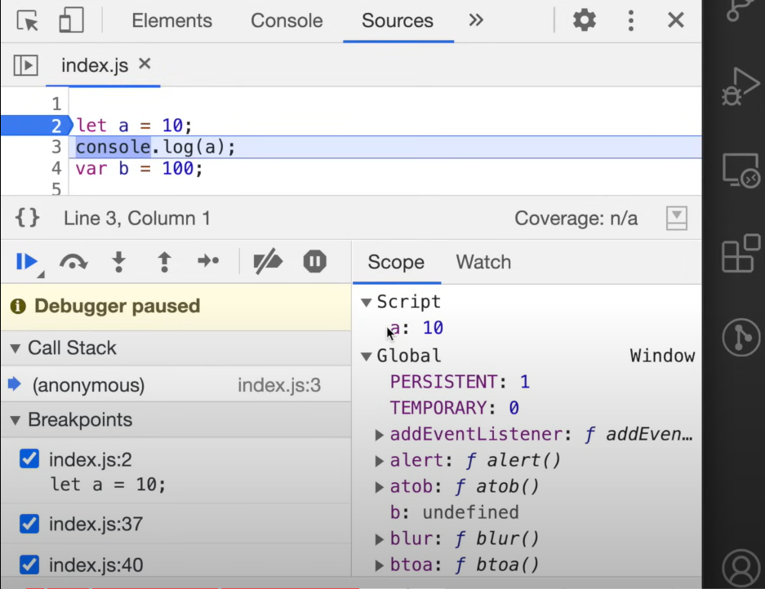

Now gng to next line , a got value assigned to 10 , but still in separate mem but can access , not console get printed

Temporal dead zone – is the time since the let variable is hosited to till it initialize a value. Time between them is known as temporal dead zone

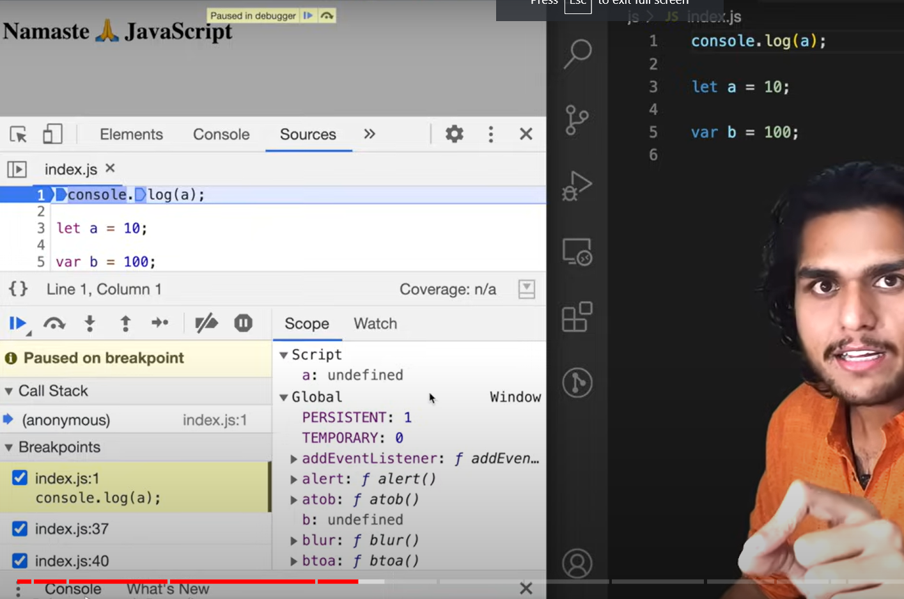

Added a debugger at console.log(a) ; u can notice a :undefined

* Let variable a got hoisted ,but not initialized, this phase is known as temporal dead zone

, until it goes to line no3

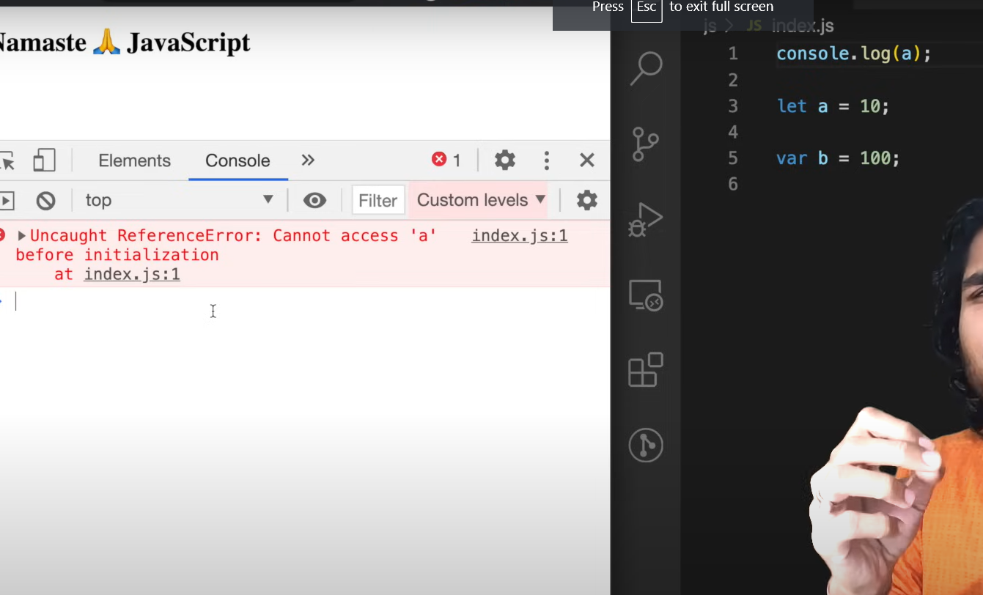

U get reference error , to access a variable inside a temporal dead zone , it gives a ref error

So u cannot access varibales inside this temporal deadzone

After this temporal dead zone , u can access

Before line no3- everything is temporal dead zone

console.log(x);

let a=10;

var b=100;

console.log(x) – a variable which is not present in pgm-

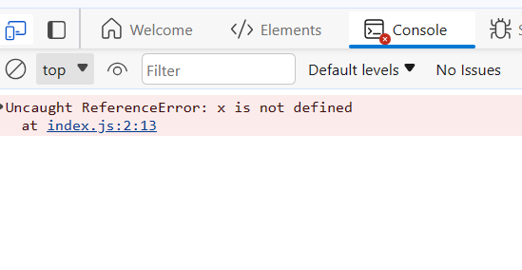

Output: ref err- x is not defined